**NPC Documentation**

**David Mason - 17098686**

**Design Justification**

The website design created for Noah’s Pet Clinic (NPC) is designed to be simple and easy to use. As pet owners come with varying ability to use technology it is important that the website can be used by all of them. In order to achieve this a few things had to be included in the design; simple consistent navigation, easy to read layout of content, appropriate design and functional access to the database.

The website was designed around 5 simple pages, this helped the navigation remain simple and allowed the users to easily view all the content on the website. To ensure the user knows which page they are on CSS styling was added to show a black colour instead of a white colour when the user is on the page. Not only is there a top navigation but throughout the pages of the website there are ‘Calls to action’ (CTA’s) encouraging the user to move through the site’s content.

The content created for the site is created to be eye catching and informative. Every page has a banner image which links to the information on the page. Furthermore, to give the user the feeling of professionalism the images sourced are high quality images e.g. no blurring. The services page details in 4 boxes an overview of the services offered by NPC. This gives the user quick, easy to read information and allows the client an easy template to build on for future services.

The website gives the user the ability to register their pet with the database to allow the vets to process their information more easily. The user can also then log into the website, the client can add to this by offering users personalised information within their logged in profile.

**Structural Design**

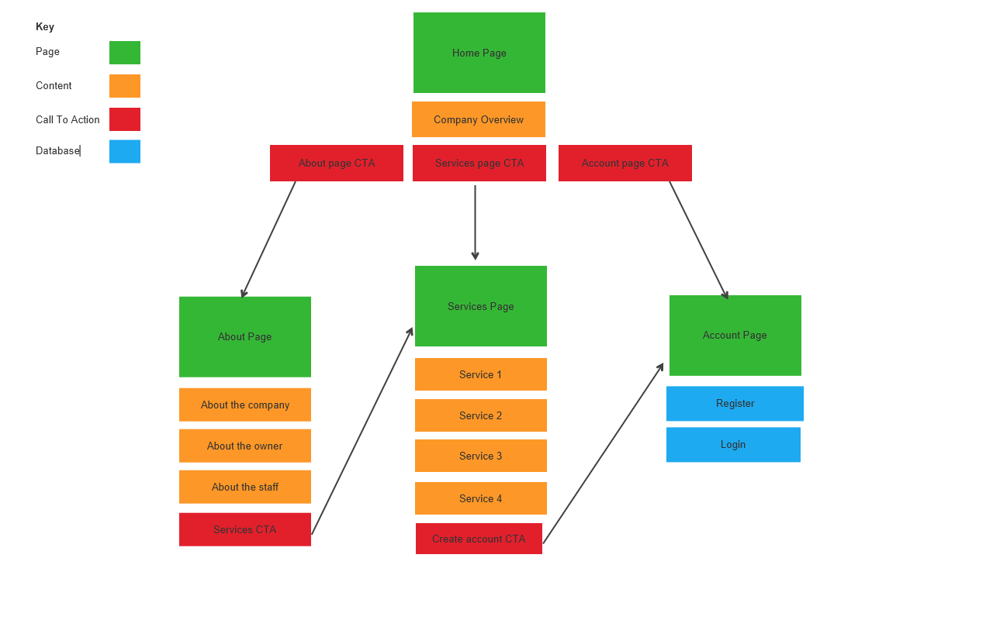

The structure of the website is designed to be simple by guiding the user through the site with easy direction by use of call to actions. Coupled with a simple navigation bar on the top of the page the content leads the user to move onto the next page.

**Detailed Design**

Page Navigation with ‘active page’ showing as black. Responsive links , when user hovers over links they turn black.

1. **Home Page**

As the header logo doesn’t include the company name its added here.

NPC Logo, transparent to blend into the header.

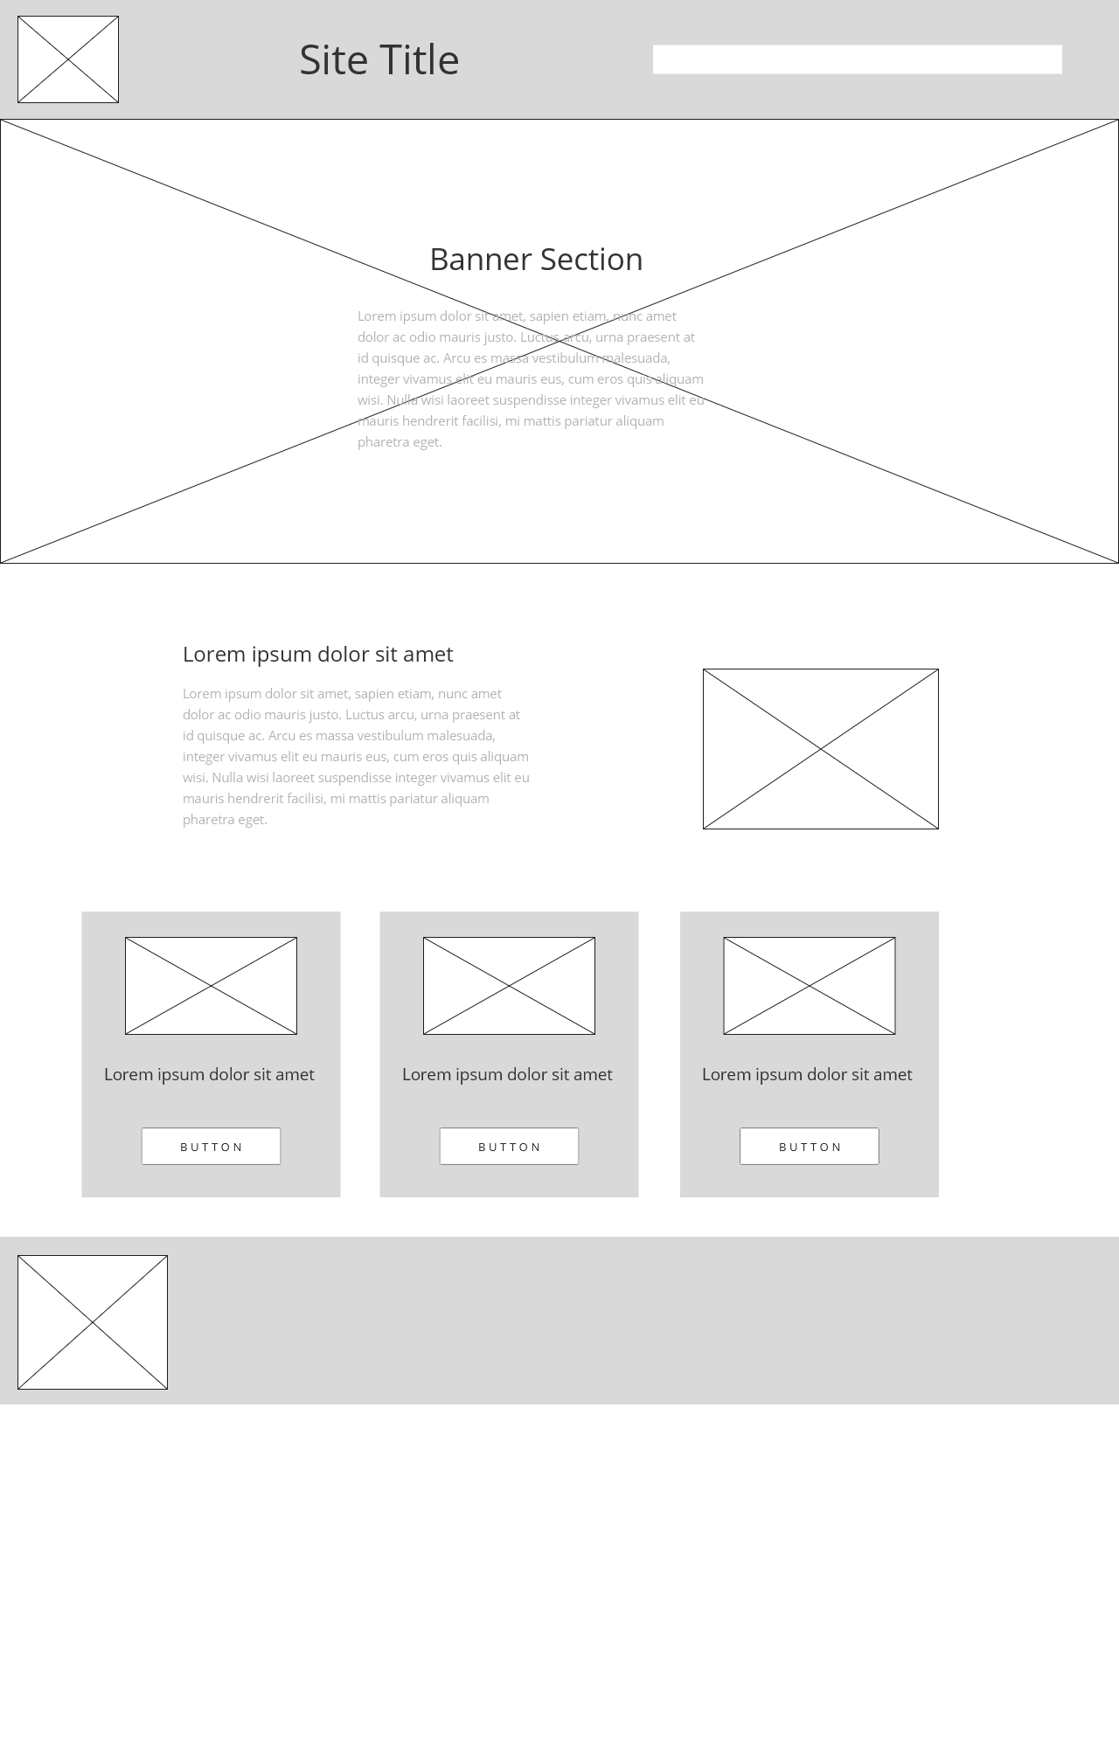

Large banner image showing a happy dog as they are NPC’s speciality

Page title and introduction. Title describes what the company does and description expands on it.

Information detailing a short overview of the company, services and animals it caters to. Linked with a logo in full colour.

Hero boxes outlining the main features of the website. Call to action headers with images linking to the pages. Leading the user to navigate to the services page, abut page and encouraging the user to register their pet.

A simple footer in the same colour as the header with the logo to reinforce the brand identity with the user.

1. **About Page**

The about page informs the user why they should choose NPC as their vet. It also builds the company image by introducing them to the owner and the staff.

Consistent header on every page. Logo, site title and navigation

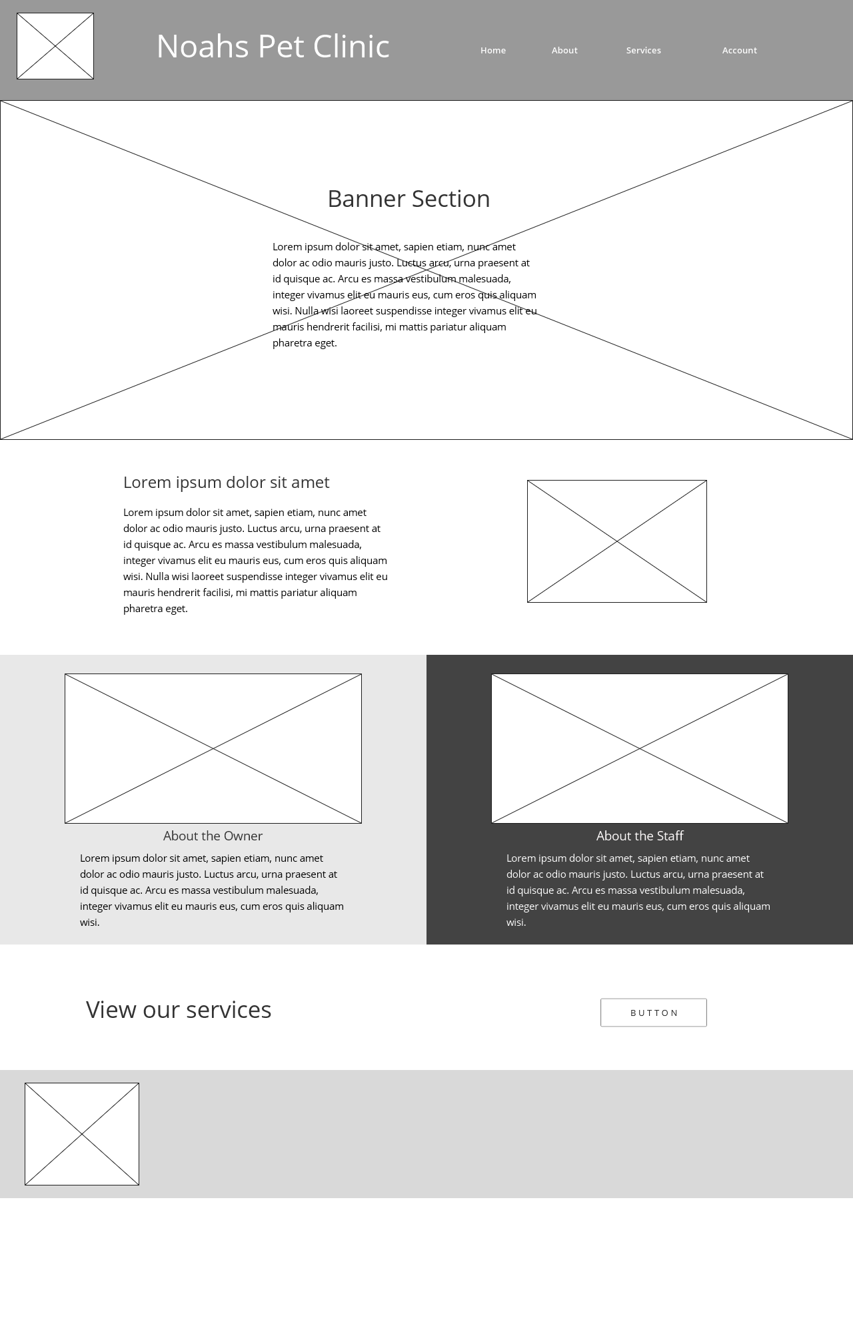

Call to action leading the user to read about NPC’s services

Same footer as all pages for continuity.

Image of Noah

Image of doctors and nurses

Information about the staff and the standard NPC expects from them.

Section about the owner (Noah), his education and the reason he started NPC

Detailed information about the company and their history.

Same introduction section as the home page to give familiarity to the user.

Banner image with a picture of the team of vets and nurses.

Page title and introduction to the information within the page.

1. **Services**

Consistent header on every page. Logo, site title and navigation

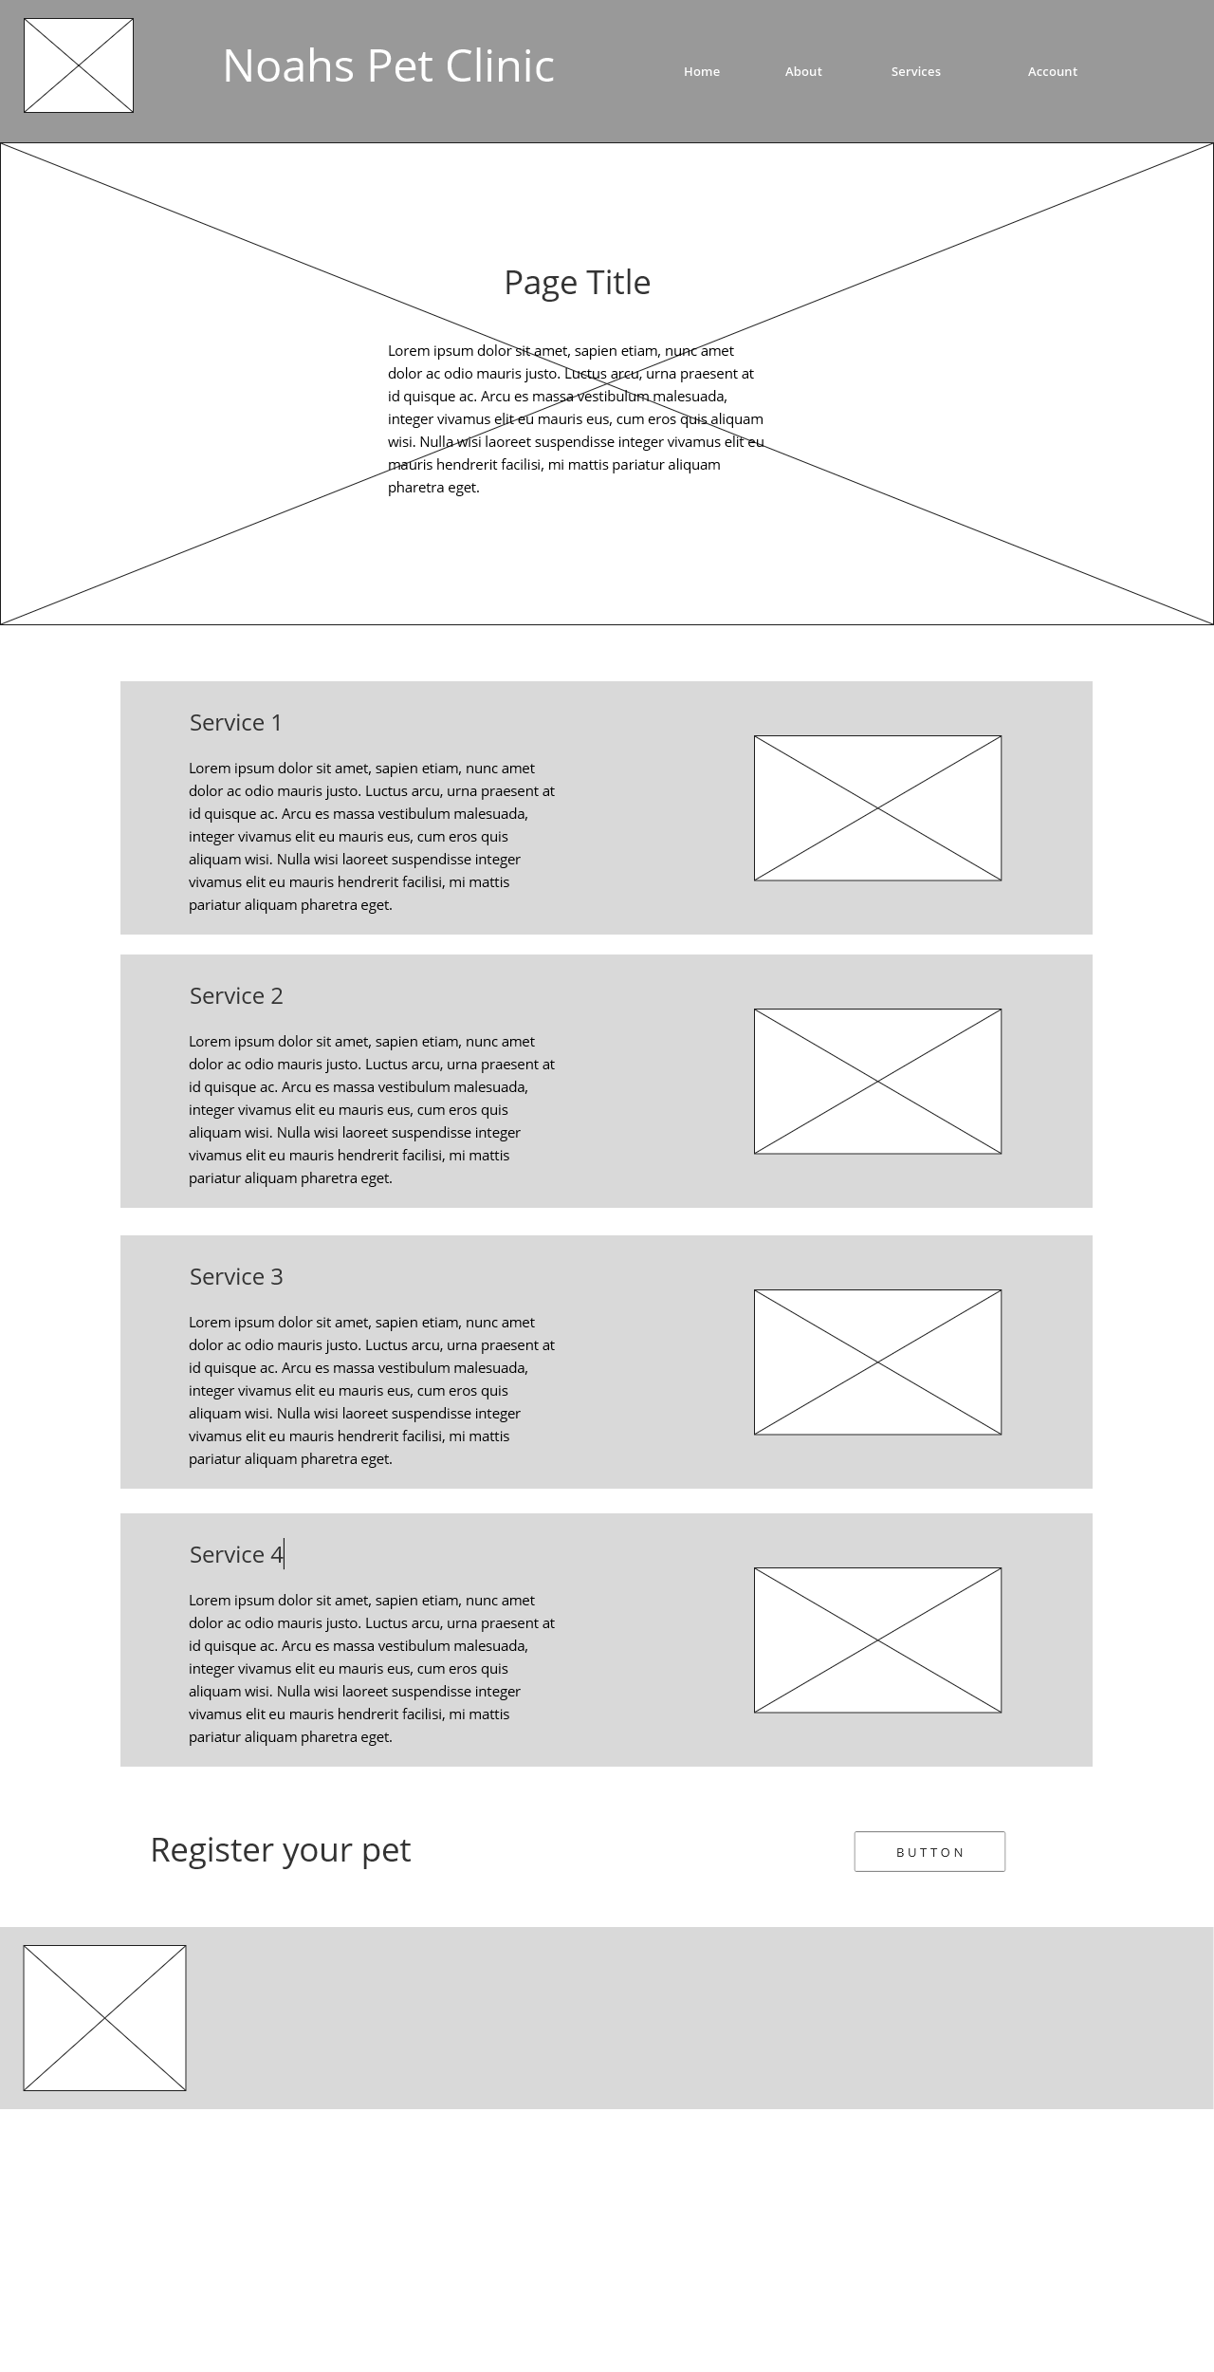

Button leading user to account page.

Same footer as all pages for continuity.

Call to action leading the user to register their pet on the website.

Service title and detailed information of what is included in the service as well as why the service is important for the users pet.

Photo album of images relating to the services

Banner image of a nurse tending to a dog. Showing the service to the user.

Page title and short overview of NPC’s services and the animals they work with.

1. **Account**

Consistent header on every page. Logo, site title and navigation

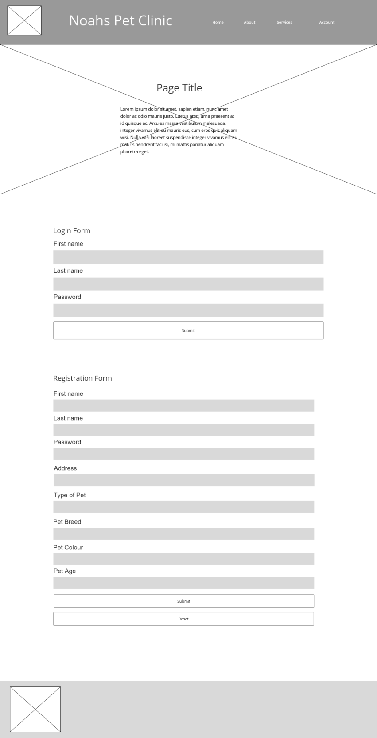

A registration page collecting all the information needed when a user wants to register their pet with the clinic. The form then sends the information to the database via PHP. There will be a message at the top of the page telling the user that their registration has been successful by printing their name and animal breed.

Once the user has registered using the form they can then enter their first name, last name and password to login to the website. When the form is submitted the PHP code checks with the data base to check if the details are correct. The site then tells the user if their log in has been successful or not.

Page title and information telling the user what to do on the page.

Banner image of doctor gear and notepads to suggest appointments.

Same footer as all pages for continuity.

**Design Evaluation**

To ensure that the design of the website is effective it was tested with two subject to gather their thoughts, opinions and suggested improvements. The method used to evaluate the website with the subjects was the gruella testing method. This is a low cost method of capturing feedback ‘in the field’ in an informal manner (Box UK, no date).

The test involved setting two users tasks to complete on the website and asking them to use ‘think aloud’ techniques through each step to describe their thoughts about the functionality, design and layout of the website.

**The tasks the users were asked to complete were:**

1. Find out what services NPC offers
2. Find where the owner went to University
3. Register on the website
4. Login to the website

**Results from subject 1**

Positive

* The layout of the page is clear and easy to read
* The navigation of the website is simple with clear instructions where to go next.
* The registration form is easy to use.

Negative

* The logo is used a lot around the website where pictures could be used
* The alignment of some sections is off making the page look messy.
* The notification for a successful/unsuccessful registration isn’t near the registration from.

**Results from subject 2**

Positive

* The images used are high quality
* The content is informative and in a place that is expected

Negative

* The colours of the website are inconsistent
* Some areas of the page aren’t responsive

**Actions from results**

From the testing it was pointed out that although the website is responsive some aspects of the website needed to be adjusted to look cleaner when changing the size of the screen.

The colours throughout the website will be reviewed to ensure that sections are using a consistent colour scheme that ensure content is easy to read by the user.

The registration notification will be moved to closer to the registration form to make it clearer to the user.

**References**

Box UK. *Unboxing: guerrilla usability testing.*[Online] [Accessed on 26/02/20] <https://www.boxuk.com/insight/unboxing-guerrilla-usability-testing/>